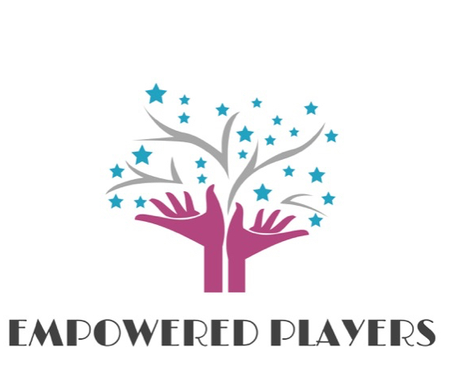
Changing the world, one show at a time.

Empowered Players is a Fluvanna-based nonprofit 501(c)(3) designed to make a difference in the community through the arts. We promote youth empowerment, are dedicated to community service, and believe the arts have the power to unite.

Mission: Our mission is to uplift the human spirit through access to quality arts experiences, youth empowerment, and community service.

Vision: Empowered Players seeks to uplift the human spirit by bringing quality arts experiences to people who may not have access to live theater performances or classes. By providing free classes and performance opportunities for children, and through volunteering in various charity and community events, we strive to spread the transformative power of the arts to unite us all. Empowered Players is committed to collaborating with schools, community groups, and other organizations to promote the arts in underserved communities.
What We Do:
- Offer accessible education and performance opportunities for young people.
- Provide opportunities for creative expression in the community.
- Expose young people to the magic of the performing arts, and share the joy of working together.
- Cultivate an environment where young people can grow and thrive, both as individuals and as members of a cooperative team.
Programs
Introductory Acting Classes
- Theater games
- Acting techniques, improvisation, vocal training, etc.
Arts Enrichment Classes
- In-depth scene & character study, advanced choreography, supporting team development, offering technical theatre classes, instructing on other theatre topics, etc.
Acting Troupes (Elementary, Middle-School, and High-School) and Performances
- Advanced work with monologues, one-act productions, vocal study & movement
- Musical theater & plays, and acting for film & video
Student Arts Mentors
- Offering advanced performance skills, leadership training, and team building
- Technical design, directing, and stage management skills
Special Topics Classes
- Specialized semester-long classes on various topics and subjects
- Vocal, acting, visual arts, and movement classes
Changing the world, one show at a time.

OUR VISION
Empowered Players seeks to uplift the human spirit by offering quality arts experiences to area youth and families. By providing free classes and performance opportunities for children, and through volunteering in various charity and community events, we strive to spread the transformative power of the arts to unite us all.

DESCRIPTION
Empowered Players is a 501(c)(3) nonprofit designed to provide quality and collaborative arts training and experiences to families and children in rural communities. To achieve its goals, EP is seeking Arts Education and Arts Administration Interns and volunteers to assist with program planning, service delivery, expansion of the reach of EP, and with marketing and fundraising activities.

INSTRUCTORS/TEACHING ARTISTS
The Empowered Players teaching artists & instructors program offers educators a hands-on opportunity to learn about the operations and teaching structure of a nonprofit, community-based youth outreach and arts education organization. Weekly activities may involve helping prepare lesson plans, teaching classes in acting, voice, movement, improvisation, and other theater-related activities, leading rehearsals, helping direct performances, leading after-school classes, and helping with camps, classes, and performance.
Arts Educators must be able to work collaboratively, convey lessons and messages to students of all ages, seeking to engage youth in the creative process with respect and enthusiasm. Candidates should have coursework or experience in education, drama, humanities, and/or other related fields, show initiative, be dedicated, be skilled in multitasking, and have a passion for the arts.

Candidates should also have 10 hours available for work a week and a willingness to continue work through the school semester.

SOCIAL MEDIA MANAGER
The Social Media Manager will create, schedule, and post 2-3 times / week to Empowered Players social media, and assist with the management of Empowered Players Wix website. This management includes creating graphics, engaging with followers, and promoting events.
Candidates should have some experience with graphic design (Canva, Illustrator, etc.) and a passion for social media engagement. This role will require ~3-5 hours a week, and will be ongoing per the availability of the manager.

Internship Program
Roles & Responsibilities

Instructor
- Assist in leading games, activities, and rehearsals to foster students’ connection and artistic development
- Connect with smaller groups of students to lead instruction and provide feedback, in tandem with other instructors
- Teach for at least 1 hour a week
- Fill in for other instructors, as needed
- Adhere to professional work standards including regular attendance, punctuality, working within agreed upon hours, and abiding by all code of conduct policies
- Meet professional work obligations as discussed with Artistic Director

Teaching Artist
- Help create lesson plans for weekly classes and rehearsals in collaboration with other instructors
- Prepare original materials for students, as needed
- Lead classes on various topics per the teaching artist’s abilities & interests
- Teach for at least 2 hours a week
- Adhere to professional work standards including regular attendance, punctuality, working within agreed upon hours, and abiding by all code of conduct policies
- Meet professional work obligations as discussed with Artistic Director

Social Media Manager
- Provide ~5 hours/week of support in generating social media content, particularly for the platforms Instagram, Facebook, and Twitter
- Communicate the story of Empowered Players through engaging digital content
- Create graphics using graphic design software (Canva, Illustrator, Photoshop, etc.) to share
- Help promote events and manage event advertising & registration, as needed
- Work to expand Empowered Players follower base to a broader audience, and keep the website up to date with information
- Adhere to professional work standards including regular attendance, punctuality, working within agreed upon hours, and abiding by all code of conduct policies
- Meet professional work obligations as discussed with Artistic Director

Professional Expectations
All volunteer staff members are expected to act with integrity. An important aspect of integrity involves being dependable, respectable, and professional. All members are expected to serve as role models for the students, mentors, and volunteers working with Empowered Players. Members are expected to represent Empowered Players by adhering to the mission, philosophy, and expectations at all times.
Building a better world, one show at a time.
Apply Now! To apply, please submit:
- A cover letter explaining your interest in working with Empowered Players
- A resume that demonstrates your experience
Please email your application materials to Jessica Harris, empoweredplayersvirginia@gmail.com. Please be prepared to provide the contact information of two references.
Qualifications and Skills
Preference will be given to applicants who are current students with experience or interest in curriculum design and teaching or arts administration and marketing, respectively. Candidate will need to be able to work with Word, Excel, Office Suite and Google Docs. Instructors should be comfortable working with students in grades K-10 and be able to think quickly on their feet, maintaining composure in high-energy situations. Familiarity with differentiated learning and behavioral management techniques are encouraged. Social media manager applicants should be familiar with platforms such as Facebook, Instagram, Twitter, and other internet-based tools. Applicants should be team players, organized, and responsible.
Training
Training and supervision will be provided. However, candidates must have an interest in working with young people in a positive and affirming environment. All candidates must be willing to submit to background reference checks and any other clearance as required. Work times are varied and can happen at evenings and weekends.

Equal Opportunity

At Empowered Players, we believe that an accessible, diverse, and inclusive workforce is of the utmost importance. We provide equal opportunity for all applicants and employees. All qualified applicants for employment will be considered without regard to an individual’s race, color, sex, gender identity, gender expression, religion, age, national origin or ancestry, citizenship, physical or mental disability, medical condition, family care status, marital status, domestic partner status, sexual orientation, genetic information, military or veteran status, or any other basis protected by federal, state, or local laws. We do not tolerate discrimination or harassment based on any of these characteristics and encourage applicants of any & all ages and abilities.

Compensation: $15/hour for instructors, $20/hour for teaching artists, and $15/hour stipend for social media manager
Link: www.empoweredplayers.com

